**B.M.S. COLLEGE OF ENGINEERING BENGALURU**

Autonomous Institute, Affiliated to VTU



Lab Record

**Software Engineering and Object-Oriented Modeling**

*Submitted in partial fulfillment for the 5th Semester Laboratory*

Bachelor of Engineering

in

Computer Science and Engineering

*Submitted by:*

**AKSHARA SINGA**

1BM22CS029

Department of Computer Science and Engineering

B.M.S. College of Engineering

Bull Temple Road, Basavanagudi, Bangalore 560 019

Mar-June 2024

**B.M.S. College of EngineerinG**

**DEPARTMENT OF COMPUTER SCIENCE AND ENGINEERING**



***CERTIFICATE***

This is to certify that the Object-Oriented Modeling(23CS5PCOOM) laboratory has been carried out by Akshara Singa (1BM22CS029) during the 5th Semester Oct24-Jan2025.

Signature of the Faculty Incharge:

NAME OF THE FACULTY:Dr Sandhya.A.Kulkarni

Department of Computer Science and Engineering

B.M.S. College of Engineering, Bangalore

Table of Contents

|  |
| --- |
| 1. Hotel Management System |
| 1. Credit Card Processing |
| 1. Library Management System |
| 1. Stock Maintenance System |
| 1. Passport Automation System |

1. Hotel Management System

|  |
| --- |
| Problem Statement |
| SRS-Software Requirements Specification |
| Class Diagram  Requirements: Minimum 7 classes, 4 attributes and 4 operations in each class, associations, association name, association end names, multiplicity, association class, enumeration, qualified association, aggregation, composition, generalization, ordered, sequencing, multiplicity of attribute, brief description of the Class diagram |
| State Diagram: one simple state diagram, one advance state diagram (either Sub Machine or Nested State, include any one of the concurrency in your design)  Requirements: minimum of 6 states for both the state diagram with state name, do activities, events, guard condition, brief description of State diagram |
| Use-Case Diagram: Minimum 5 use cases to be identified, and design one simple use case diagram and one advanced use case diagram(ie using include,extend and generalization relationship) and explanation as there in the solution manual. |
| Sequence Diagram: Write the scenario for any two use case transaction completely.  and design the simple sequence diagram with minimum of 5 objects and communication between them.  Design advanced sequence diagram using passive and transient objects. Brief explanation for each |
| Activity Diagram: Design the simple activity diagram showing the algorithm or workflow. Design the advanced activity diagram with swimlanes showing the responsible person for swimlane and also write the brief explanation for both. |
|  |

Format to be Followed

-Line spacing 1.5  
-Font: 12 points - Times New Roman  
-Margin: 1.5 inch left and 1 inch on all other sides

-Text should be justified  
-Lab record report should be soft bounded (Note: Spiral bound will not be accepted). Soft bound should be with brown color cello tape and cream color sheet to be used.  
-Figure and Tables must be numbered

1. **Hotel Management System**
   1. Problem Statement: Hotels often face challenges in managing their daily operations efficiently, such as handling reservations, managing room availability, billing, staff management, and customer service. Traditional systems or manual methods are time-consuming, error-prone, and do not scale well with growing customer demands.
   2. SRS-Software Requirements Specification

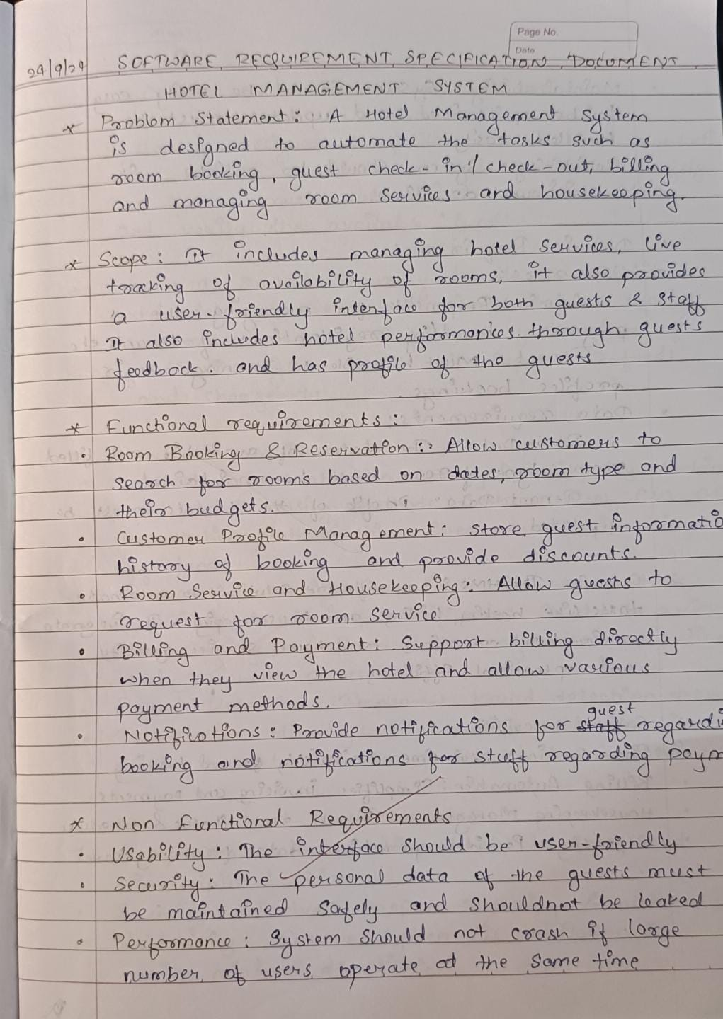

Fig 1.2.1

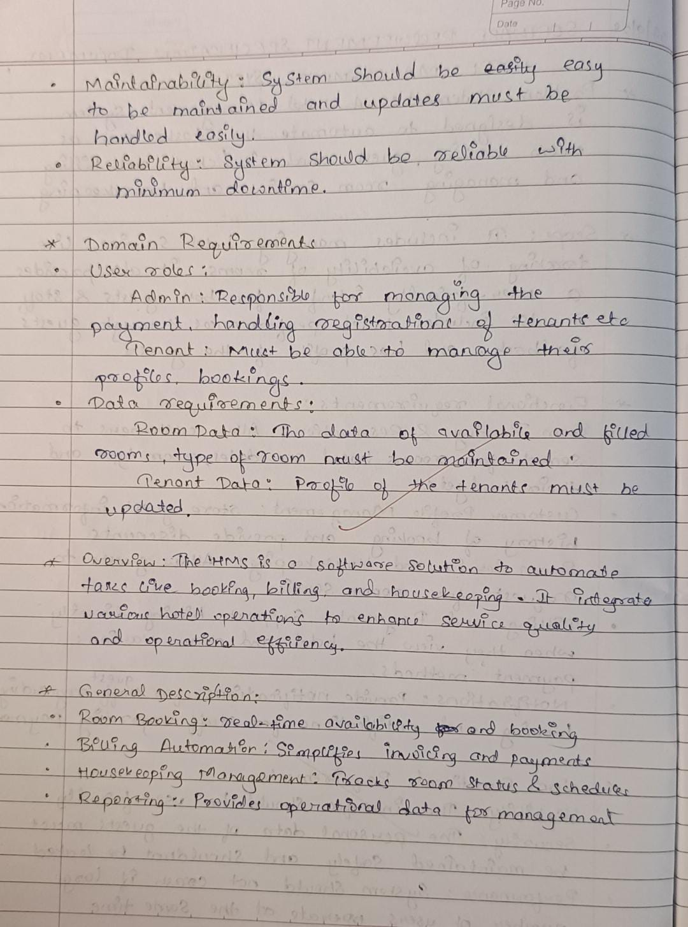

Fig 1.2.2

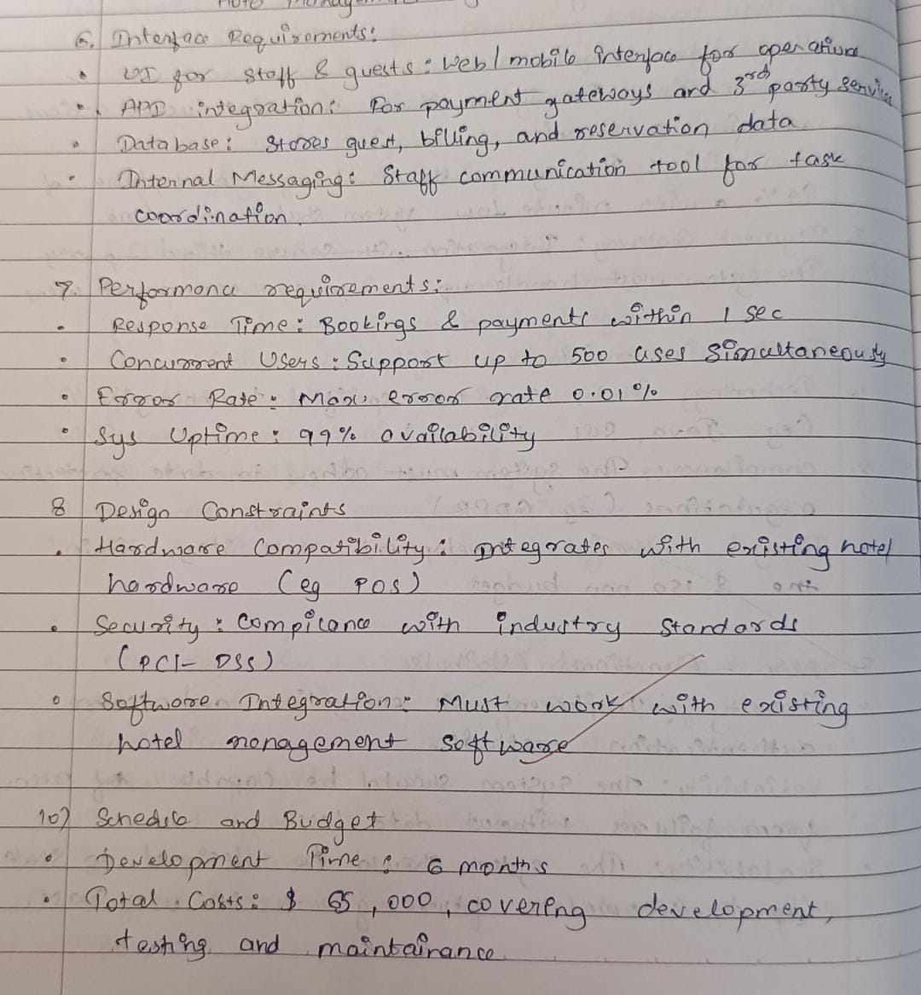

Fig 1.2.3

* 1. Class Diagram

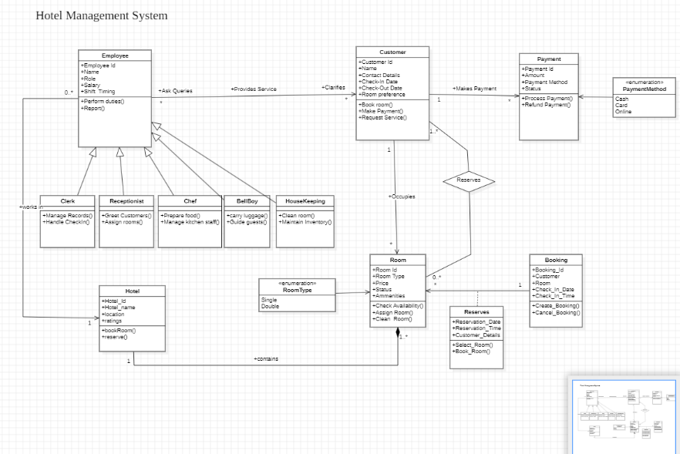

Fig 1.3.1

The class diagram represents the structure of a **Hotel Management System**, detailing the relationships and interactions among various entities. The primary entities include Employee, Customer, Room, Booking, Reserves, Payment, and Hotel. The Employee class serves as the parent for roles such as Clerk, Receptionist, Chef, BellBoy, and Housekeeping, each having specific duties like managing records, assigning rooms, preparing food, assisting guests, and maintaining room cleanliness. The Customer class holds details such as name, contact information, check-in/out dates, and room preferences, along with methods for booking rooms, making payments, and requesting services. The Room class defines attributes like room type (Single or Double), price, status, and amenities, and includes methods for checking availability, assigning, and cleaning rooms.

The Booking class manages the room booking process with details such as booking ID, customer, room, and check-in time, while the Reserves class handles room reservations and facilitates the selection and booking of rooms. The Payment class manages financial transactions, supporting various payment methods (cash, card, or online) and processes such as payment and refund handling. The Hotel class encapsulates the overall hotel entity, including details like the hotel name, location, and ratings, and connects to rooms for booking and reservation purposes. The diagram demonstrates how employees provide services to customers, who, in turn, reserve and occupy rooms while managing payments, ensuring a structured and efficient hotel management workflow.

* 1. State Diagram

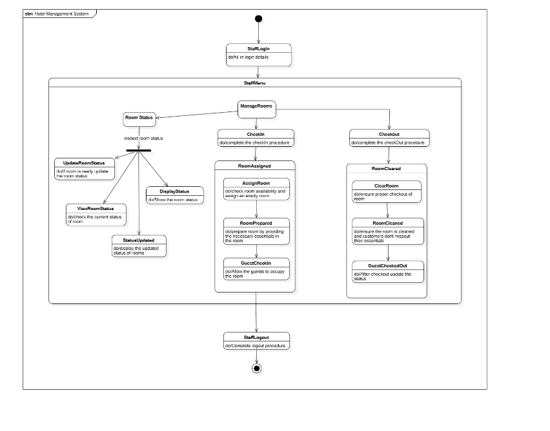

Fig 1.4.1

The state diagram represents a Hotel Management System and outlines the workflow for managing hotel operations efficiently. It begins with the **Staff Login**, where employees access the system. The primary state is the **Staff Menu**, which branches into three key functions: **Room Status**, **Check-In**, and **Check-Out**. In **Room Status**, staff can view, update, and display the current status of rooms (e.g., vacant, occupied, or under maintenance). The **Check-In** process involves assigning a room, preparing it with necessary essentials, and allowing guests to occupy it. The **Check-Out** process handles clearing the room, cleaning it, and updating its status for the next guest. Finally, the system transitions to the **Staff Logout**, where employees log out after completing their tasks. This diagram ensures a structured approach to hotel management, covering room readiness, guest handling, and status updates.

* 1. Use Case Diagram

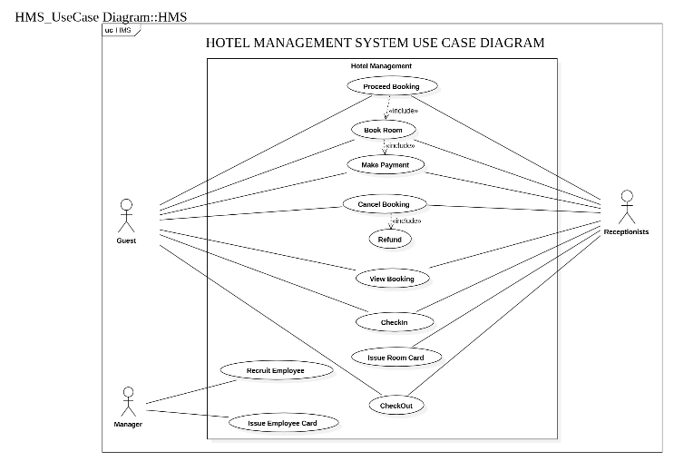

Fig 1.5.1

The use case diagram illustrates the functionality of a Hotel Management System by detailing the interactions between different actors and system processes. The primary actors include **Guests**, **Receptionists**, and a **Manager**. Guests can perform actions such as booking rooms, making payments, canceling bookings, requesting refunds, viewing bookings, checking in, and checking out. Receptionists facilitate these operations by assisting with room bookings, issuing room cards, and managing the check-in and check-out processes. The **Manager** has additional responsibilities like recruiting employees and issuing employee cards. Key use cases such as **Proceed Booking**, **Book Room**, and **Make Payment** are interconnected to ensure a smooth booking workflow. The system is designed to handle cancellations and refunds effectively while maintaining efficient guest services. This diagram provides a clear overview of the roles and responsibilities within the hotel management workflow.

* 1. Sequence Diagram

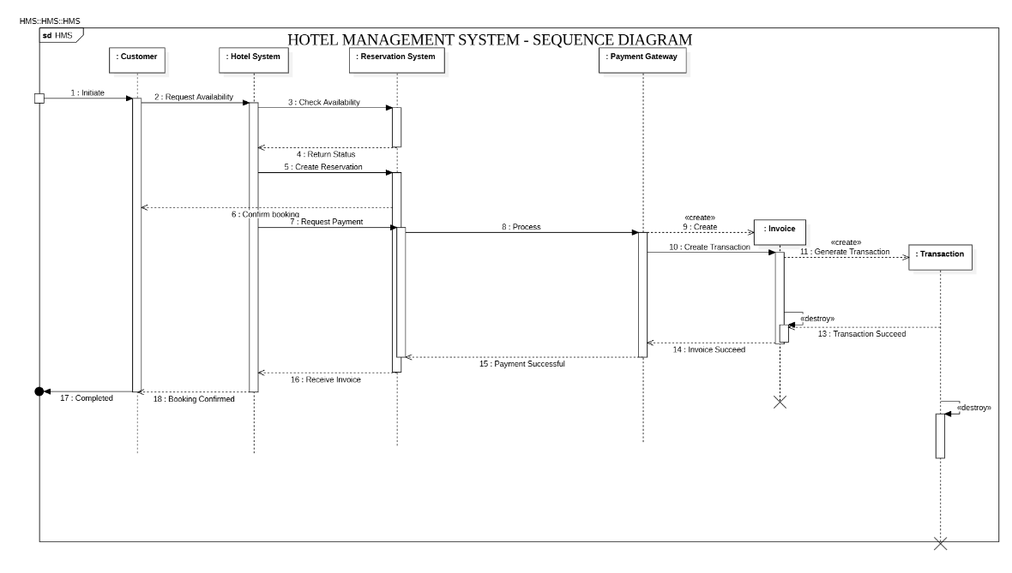

Fig 1.6.1

The sequence diagram illustrates the booking and payment process in a Hotel Management System. It begins with a **Customer** initiating a request to check room availability through the **Hotel System**, which communicates with the **Reservation System** to verify availability. The **Reservation System** returns the status to the **Hotel System**, and if a room is available, a reservation is created. The **Hotel System** then confirms the booking and sends a payment request to the **Payment Gateway**. The **Payment Gateway** processes the payment by generating an invoice and a transaction. Once the transaction is successful, the invoice is returned to the **Hotel System**, which acknowledges the payment as successful. Finally, the customer receives the booking confirmation, marking the process as completed. This diagram ensures a streamlined interaction between customer requests, reservation handling, and secure payment processing.

* 1. Activity Diagram

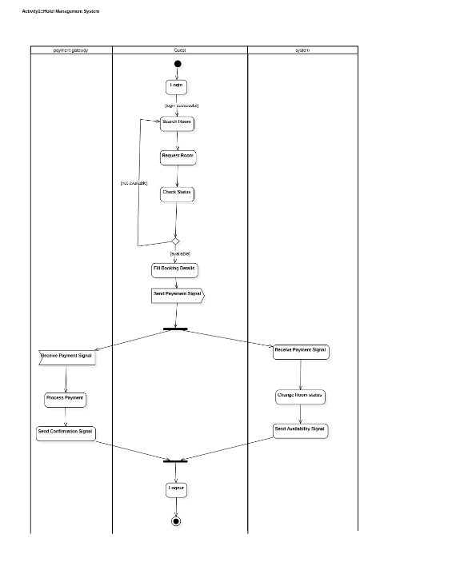

Fig 1.7.1

This activity diagram depicts the activity flow for a hotel room booking process. It involves three participants: the guest, the system, and the payment gateway. The guest begins by logging in and searching for available rooms. Upon finding a suitable room, they request it, and the system checks its availability. If available, the guest fills in booking details and sends a payment signal. This triggers parallel actions: the payment gateway processes the payment and sends a confirmation signal if successful, while the system simultaneously changes the room's status to booked and sends an availability signal. Finally, upon receiving both signals, the process concludes with the guest logging out. This diagram illustrates the sequential and parallel activities involved in a typical online hotel room booking scenario.

1. **Credit Card Processing System**
   1. Problem Statement: Financial institutions and merchants face challenges in securely and efficiently managing credit card transactions. The process involves verifying customer details, processing payments, fraud detection, and ensuring regulatory compliance. An unreliable or inefficient system can lead to transaction delays, increased risks of fraud, and poor customer experience.
   2. SRS-Software Requirements Specification

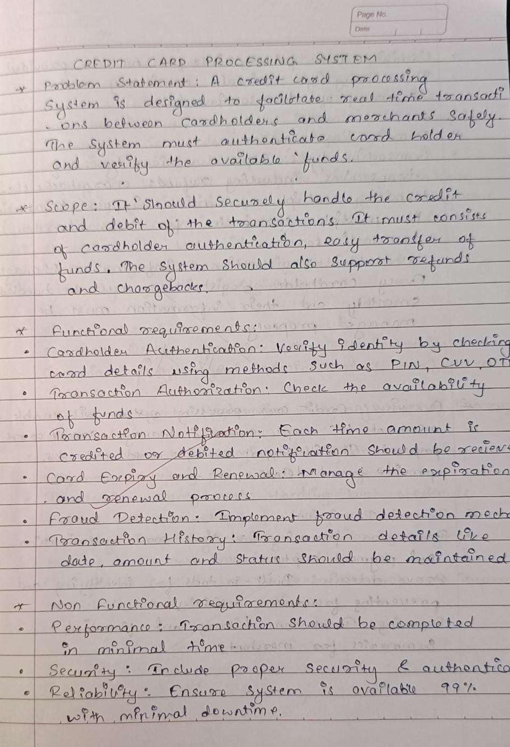

Fig 2.2.1

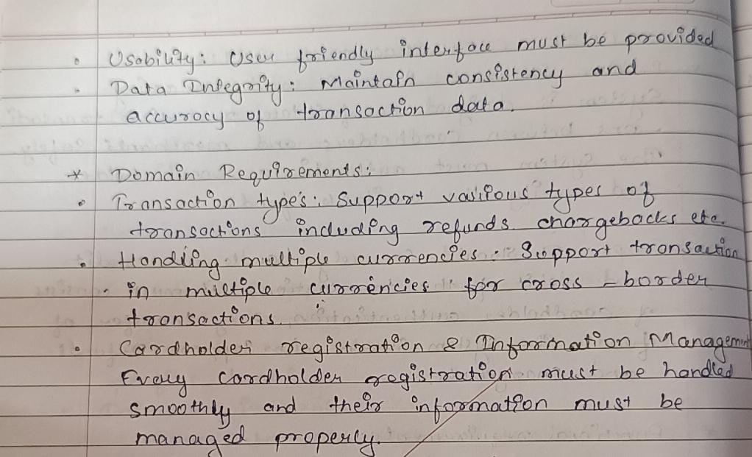

Fig 2.2.2

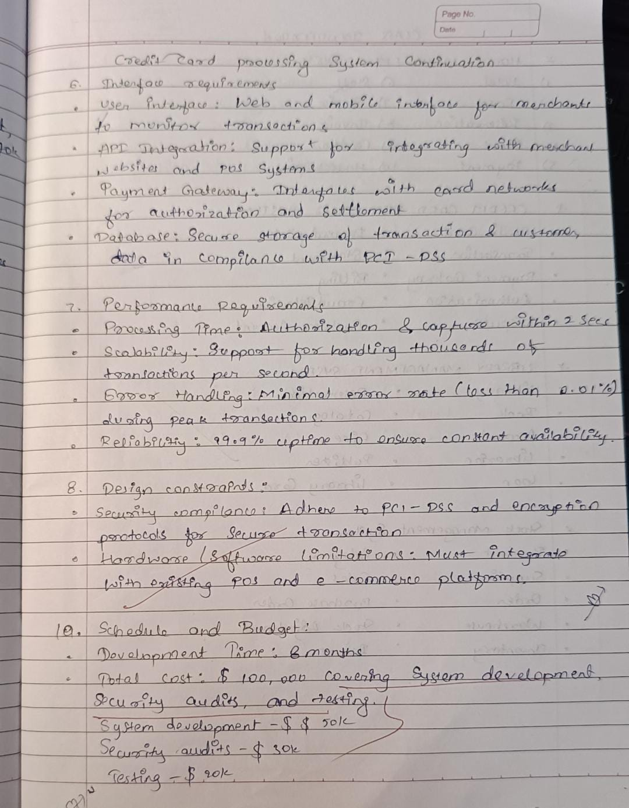

Fig 2.2.3

* 1. Class Diagram

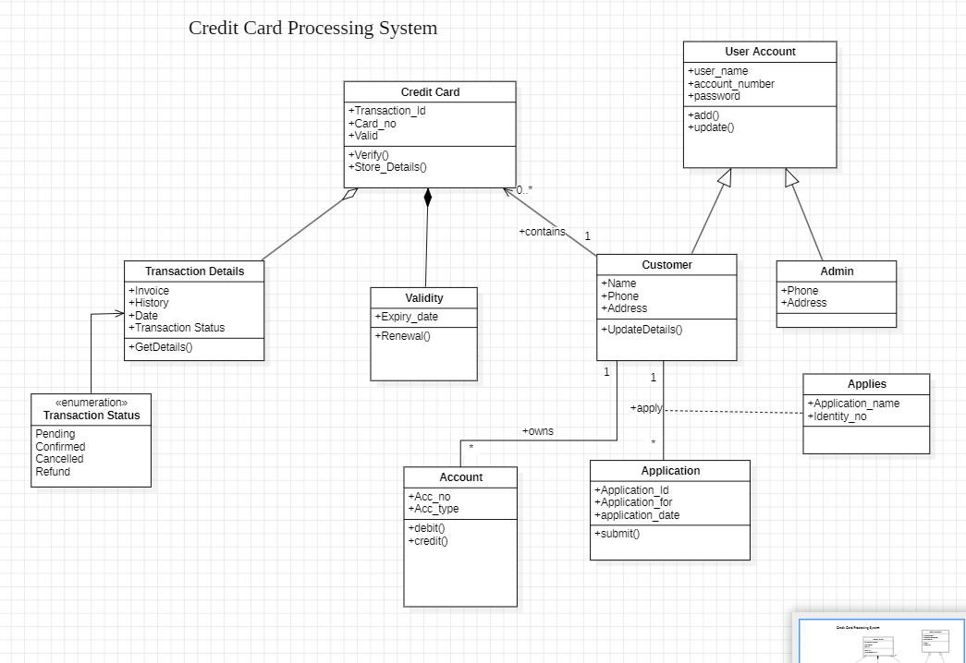

Fig 2.3.1

This UML class diagram models a credit card processing system. It shows that a Transaction uses a Credit Card and contains Transaction Details. Each Credit Card has a Validity status. A Customer can have multiple Accounts and submit Applications for credit cards, which are also linked to an Account. An Admin manages Customers and their Applications. The diagram also lists attributes for each class, like card number for Credit Card and transaction date for Transaction, as well as operations like verify() for Credit Card, debit() and credit() for Account, and submit() for Application. This structure defines the core components and their interactions within the credit card processing system.

* 1. State Diagram

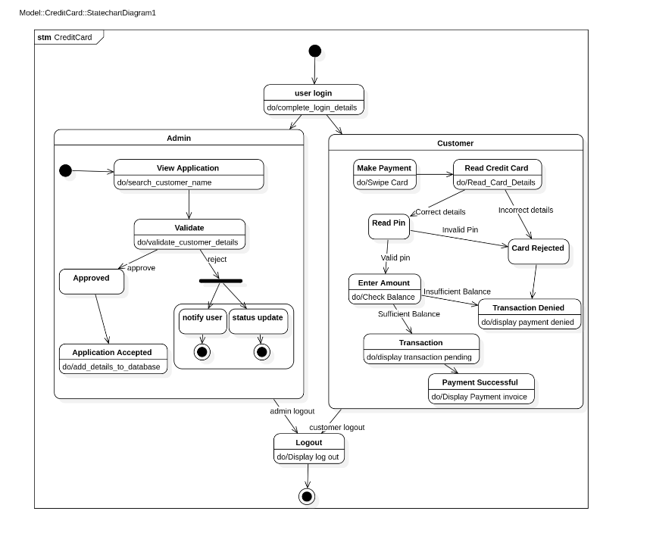

Fig 2.4.1

This state diagram models user interaction with a credit card system. Users begin by logging in, then proceed as either a Customer or Admin. Customers can "Make Payment" (involving card reading, PIN entry, and amount confirmation, leading to either successful payment or transaction denial) or "View Application." Admins can "View Application," which includes searching for applications and subsequently approving or rejecting them, updating the application status. Actions like reading card details or displaying payment invoices are associated with state transitions. The diagram clearly outlines the different paths and possible outcomes for both customer and admin users within the system.

* 1. Use Case Diagram

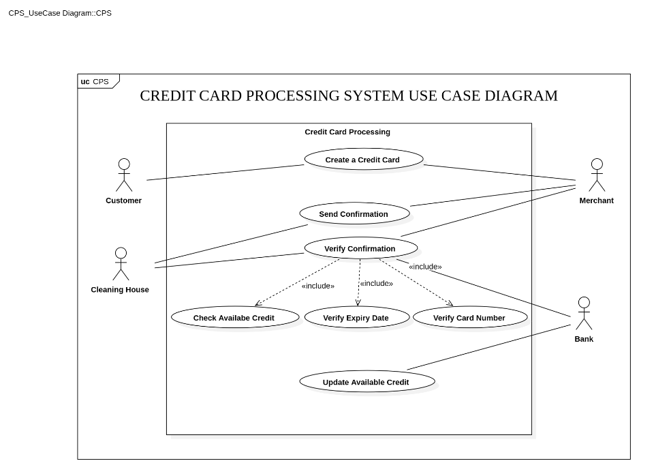

Fig 2.5.1

This use case diagram illustrates interactions within a Credit Card Processing System (CPS). It shows four actors: Customer, Merchant, Cleaning House (likely for transaction reconciliation), and Bank. The primary use case is "Credit Card Processing," which involves several included use cases. The Customer can "Create a Credit Card." The Merchant "Sends Confirmation" of a transaction, which triggers the "Verify Confirmation" use case. This verification process *includes* three sub-processes handled by the Bank: "Check Available Credit," "Verify Expiry Date," and "Verify Card Number." Finally, the Bank also "Updates Available Credit" after a transaction. The diagram highlights the dependencies and interactions between the different actors and their respective roles in the credit card transaction process.

* 1. Sequence Diagram

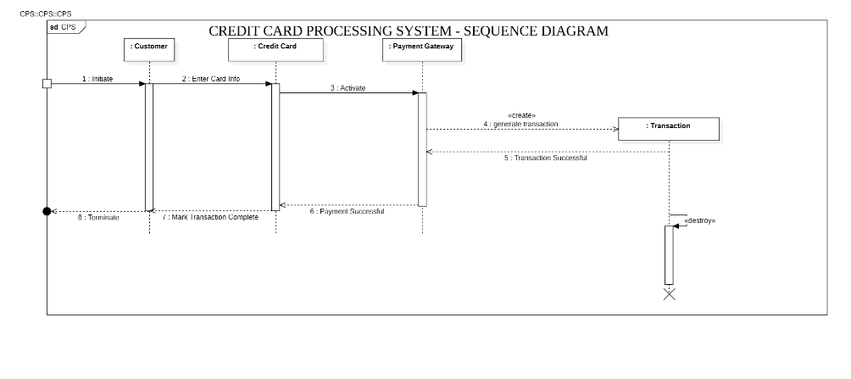

Fig 2.6.1

This sequence diagram illustrates the flow of a credit card transaction. It involves three participants: Customer, Credit Card (representing the card itself/card reader interaction), and Payment Gateway. The process begins with the Customer initiating a transaction (1: Initiate). The Customer then enters their card information (2: Enter Card Info), which activates the Payment Gateway (3: Activate). The Payment Gateway then generates a new Transaction object (4: generate transaction). Assuming the transaction is successful, the Payment Gateway sends a success message (5: Transaction Successful) back to the Customer. The Customer then marks the transaction as complete (Mark Transaction Complete), and the Payment Gateway confirms payment success (6: Payment Successful). Finally, the Transaction object is destroyed, completing the sequence. In short, the diagram shows the step-by-step interaction between the customer, their card, and the payment system during a successful transaction.

* 1. Activity Diagram

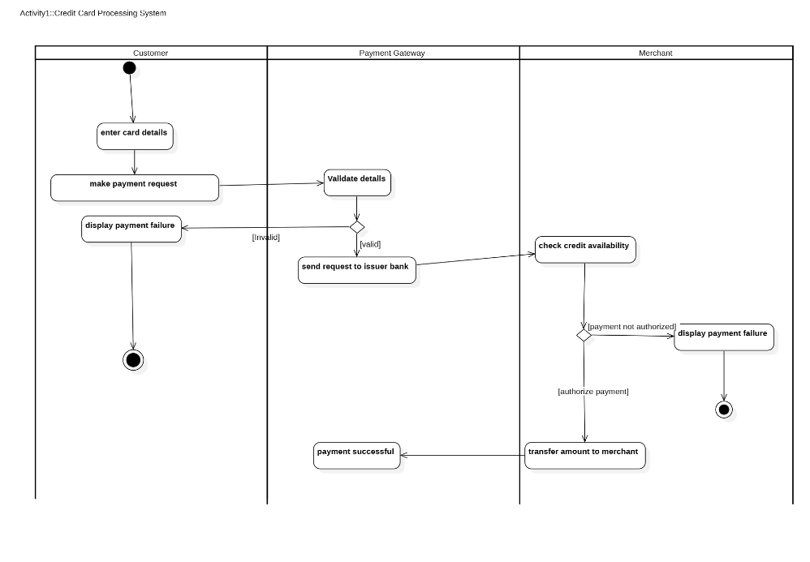

Fig 2.7.1

This activity diagram depicts the flow of a credit card transaction involving a Customer, Payment Gateway, and Merchant. The Customer begins by entering card details and making a payment request. The Payment Gateway then validates these details. If invalid, a payment failure is displayed to the Customer, and the process ends. If the details are valid, the Payment Gateway sends a request to the issuer bank, represented here by the Merchant's action of checking credit availability. If the payment is not authorized, a payment failure is displayed to the Merchant, and the process ends. However, if the payment is authorized, the amount is transferred to the Merchant, and a "payment successful" message is sent back through the Payment Gateway, completing the transaction. This diagram clearly shows the sequential steps and decision points in a credit card transaction, highlighting the interactions between the three parties involved.

1. **Library Management System**
   1. Problem Statement: Managing the operations of a library manually, such as tracking borrowed books, overdue returns, and inventory updates, is time-consuming and prone to errors. A robust system is needed to streamline these operations, improve efficiency, and enhance the experience for library users.
   2. SRS-Software Requirements Specification

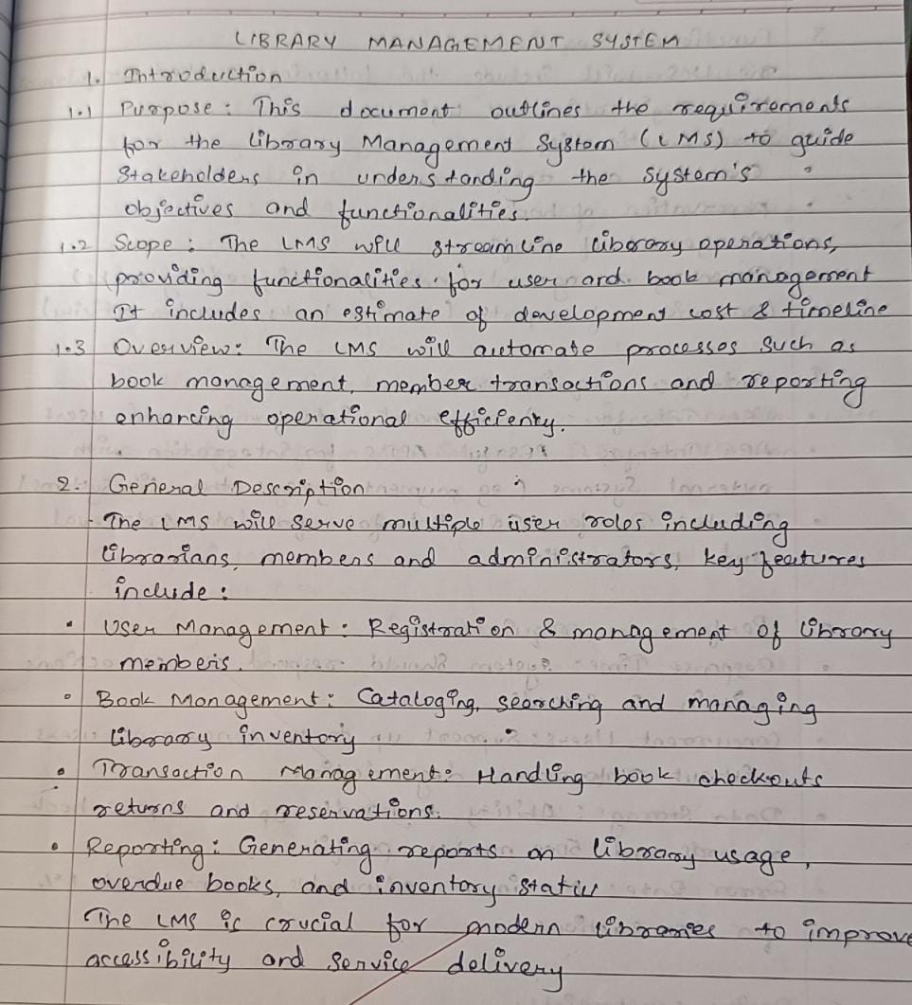

Fig 3.2.1

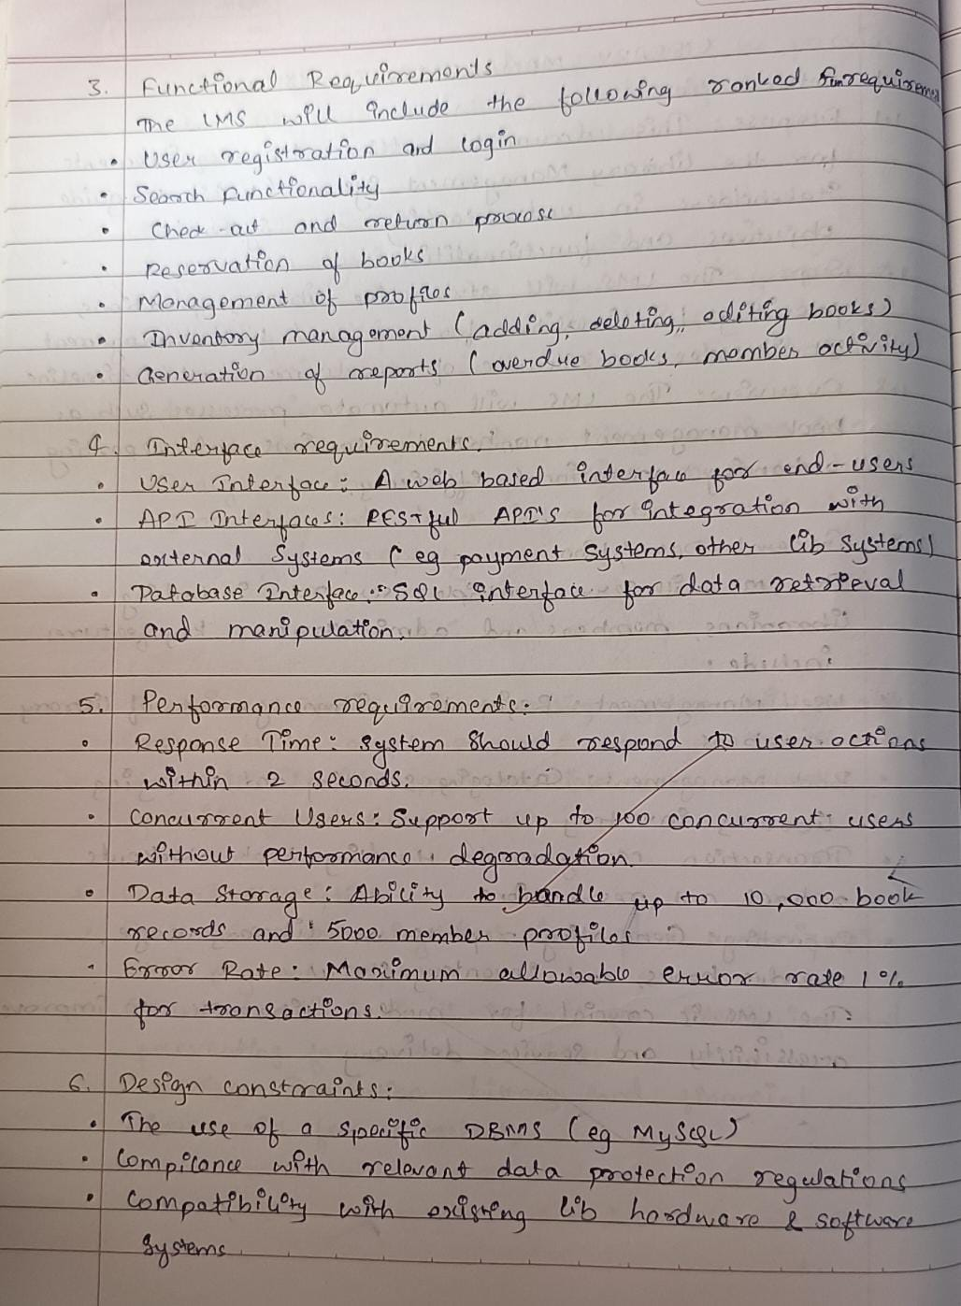

Fig 3.2.2

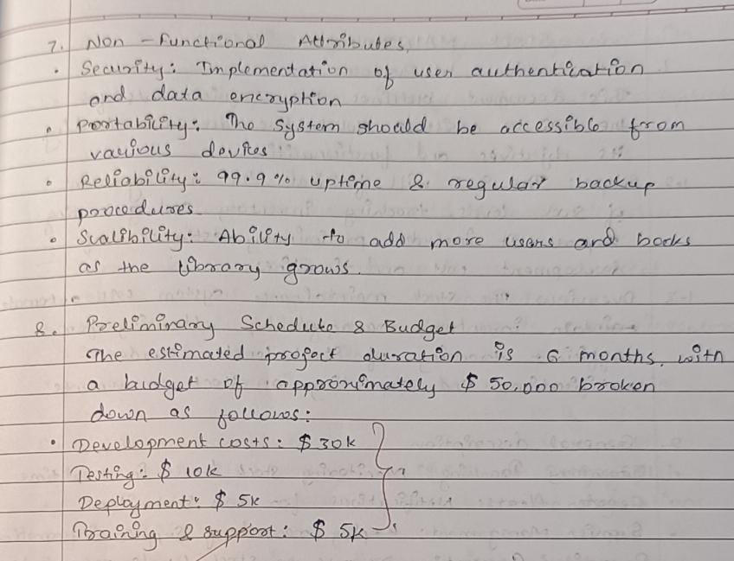

* 1. Class Diagram

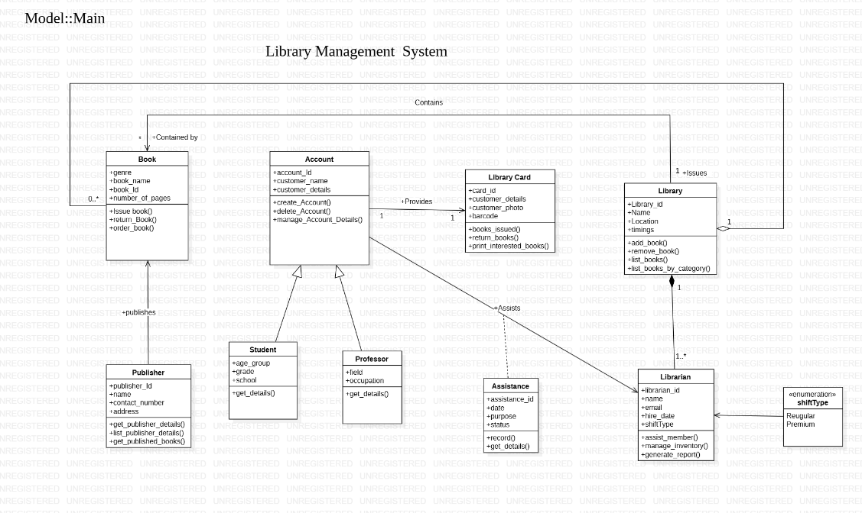

Fig 3.3.1

This UML depicts a class diagram for a Library Management System. It outlines the key entities involved and their relationships. The core entities include Book (with attributes like genre, name, ID, and number of pages, and operations like issuing, returning, and ordering), Account (with customer details and account management operations), Library Card (linking accounts to the library and tracking issued books), and Library (containing books, managing inventory, and handling book lists). These are further connected to Publisher (responsible for publishing books) and two types of library members: Student and Professor, both inheriting from Account. Finally, a Librarian assists members and manages the library, potentially with different ShiftType (Regular or Premium), and an Assistance entity tracks the details of assistance provided by librarians. The diagram illustrates how these entities interact, providing a structured view of the system's data and functionality.

* 1. State Diagram

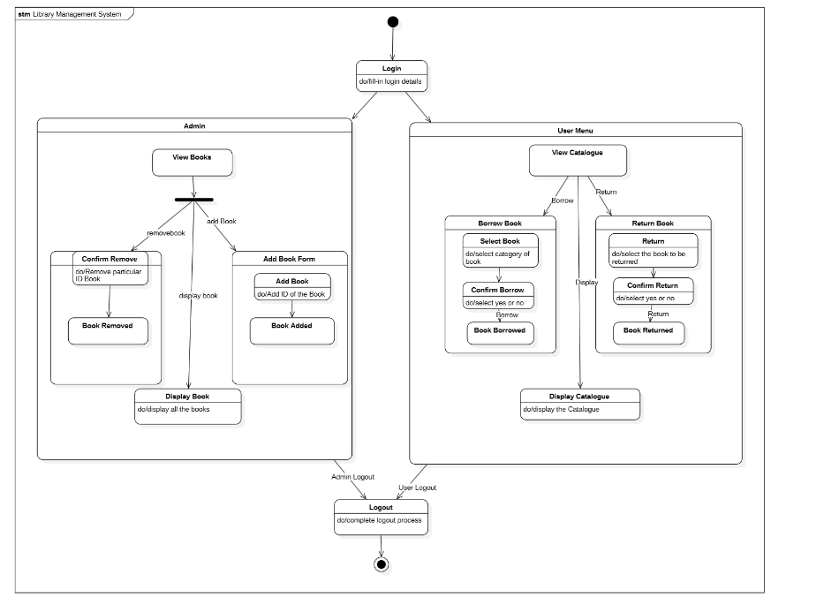

Fig 3.4.1

This state diagram for a Library Management System illustrates the system's dynamic behavior and user interactions. Starting with a login state requiring valid login details, the system branches into two main user roles: Admin and regular User. The Admin Menu allows actions like viewing books, which can lead to removing a specific book (requiring confirmation) or adding a new book via an "Add Book Form". Both removal and addition ultimately return to displaying the updated book list. The User Menu offers options to view the catalog, borrow a book (involving book selection and borrow confirmation), or return a book (with return confirmation). Both borrowing and returning books transition to a "Book Borrowed" or "Book Returned" state, respectively, before returning to the catalog display. Finally, both Admin and User roles can log out, transitioning the system to a logout state and completing the process. This diagram effectively visualizes the various paths users can take within the system and the corresponding state changes.

* 1. Use Case Diagram

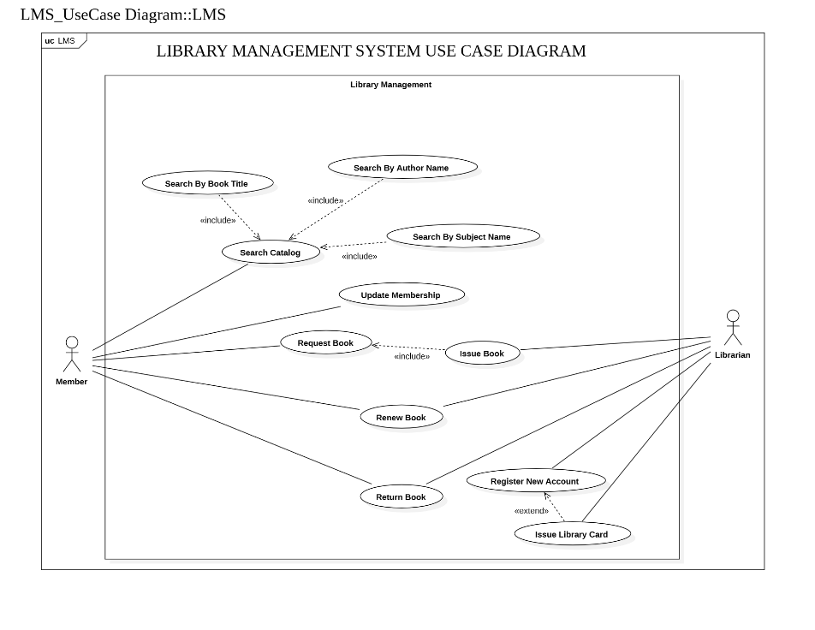

Fig 3.5.1

It represents a use case diagram for a Library Management System (LMS). It depicts the interactions between two actors, "Member" and "Librarian," and the system's functionalities represented as use cases (ovals). The "Member" actor can perform actions like searching the catalog (by book title, author name, or subject name), requesting a book, renewing a book, and returning a book. The "Librarian" actor is responsible for issuing books (which "includes" the "Request Book" use case), registering new accounts (which "extends" to "Issue Library Card"), and updating memberships. The "Search Catalog" use case is further detailed by "include" relationships with "Search By Book Title," "Search By Author Name," and "Search By Subject Name," indicating these are sub-functions of the broader search functionality. Overall, the diagram illustrates the system's scope and the services offered to members and librarians.

* 1. Sequence Diagram

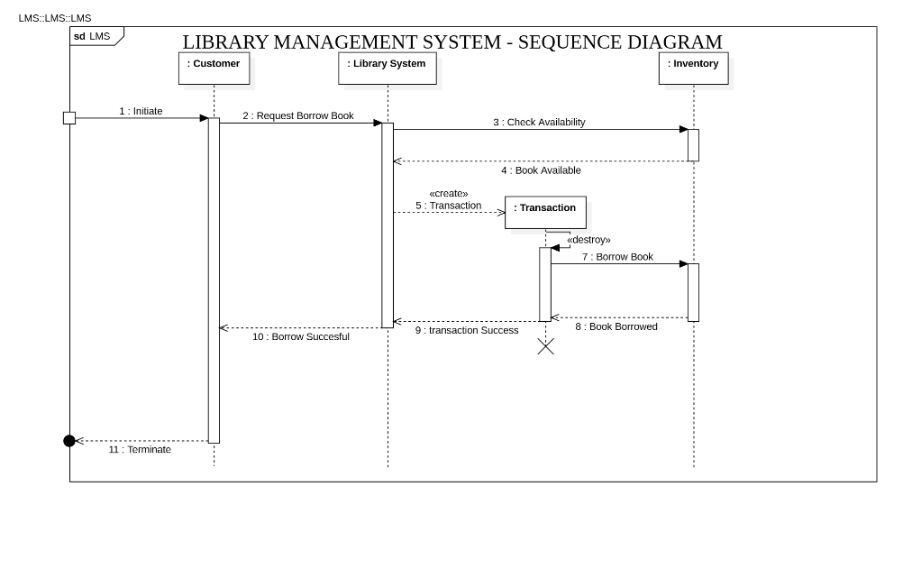

Fig 3.6.1

This is a sequence diagram for a Library Management System, specifically illustrating the "Borrow Book" use case. It shows the interactions between several objects or actors over time. The "Customer" initiates the process by requesting to borrow a book. The "Library System" then checks the availability of the book in the "Inventory." If the book is available, the system creates a "Transaction" object to record the borrowing details. The "Inventory" is then updated to reflect that the book is borrowed. The "Transaction" object is subsequently destroyed (likely after the borrowing is successfully recorded). Finally, the "Library System" informs the "Customer" that the borrow was successful, and the interaction terminates. The diagram emphasizes the chronological order of messages exchanged between the objects during the book borrowing process.

* 1. Activity Diagram

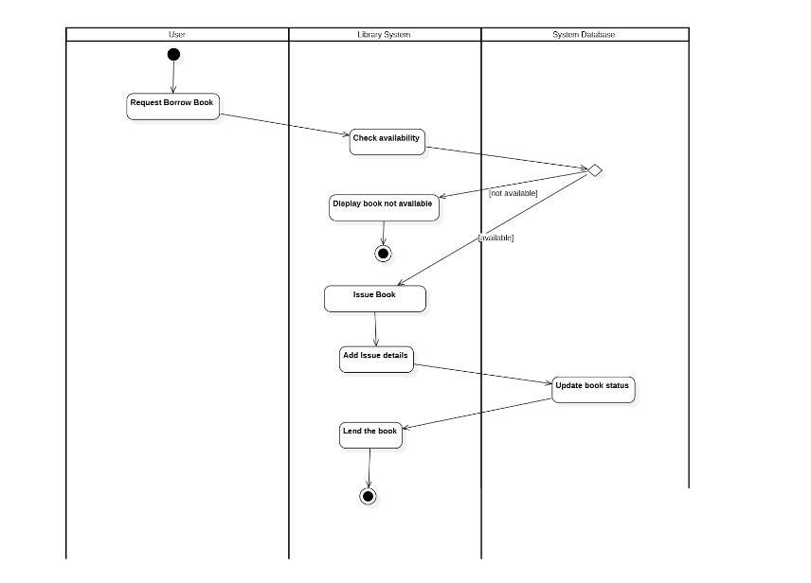

Fig 3.7.1

This is an activity diagram for a Library Management System, detailing the process of borrowing a book. It's divided into swimlanes representing the "User," "Library System," and "System Database." The process begins with the "User" requesting to borrow a book. The "Library System" then checks the book's availability in the "System Database." A decision diamond follows: if the book is "not available," a message is displayed to the user. If the book is "available," the "Library System" proceeds to "Issue Book," "Add Issue details," and updates the "book status" in the "System Database." Finally, the "Library System" "Lends the book" to the user, marking the end of the activity. The diagram clearly shows the flow of actions and responsibilities across different parts of the system during a book borrowing transaction, including the handling of book availability.

1. **Stock Management System**
   1. Problem Statement: Managing stock levels manually in a business is inefficient, prone to human error, and can lead to overstocking or understocking issues. A well-organized system is required to monitor inventory, track stock movements, and ensure the availability of items to meet customer demands efficiently.
   2. SRS-Software Requirements Specification

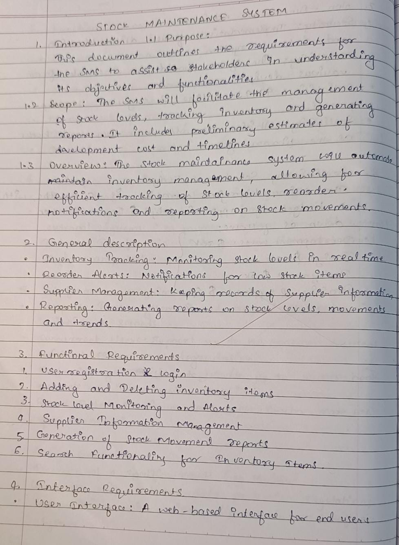

Fig 4.2.1

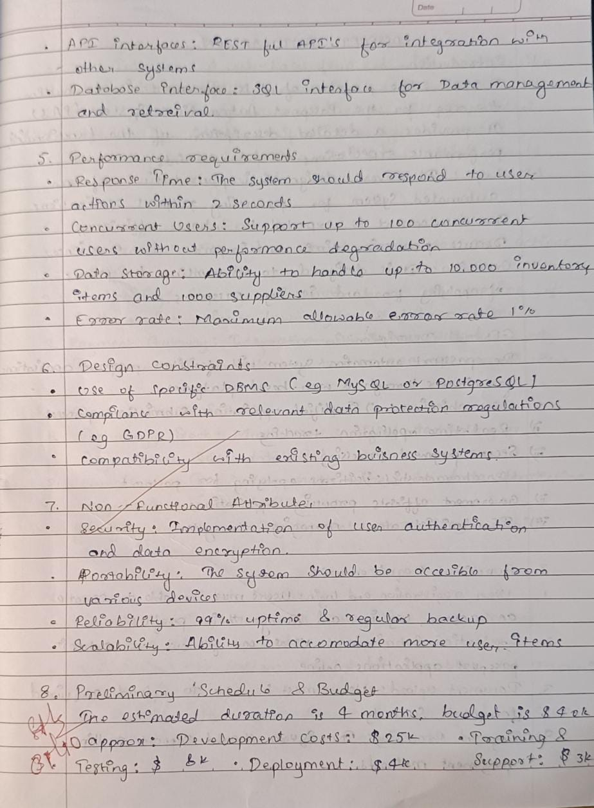

Fig 4.2.2

* 1. Class Diagram

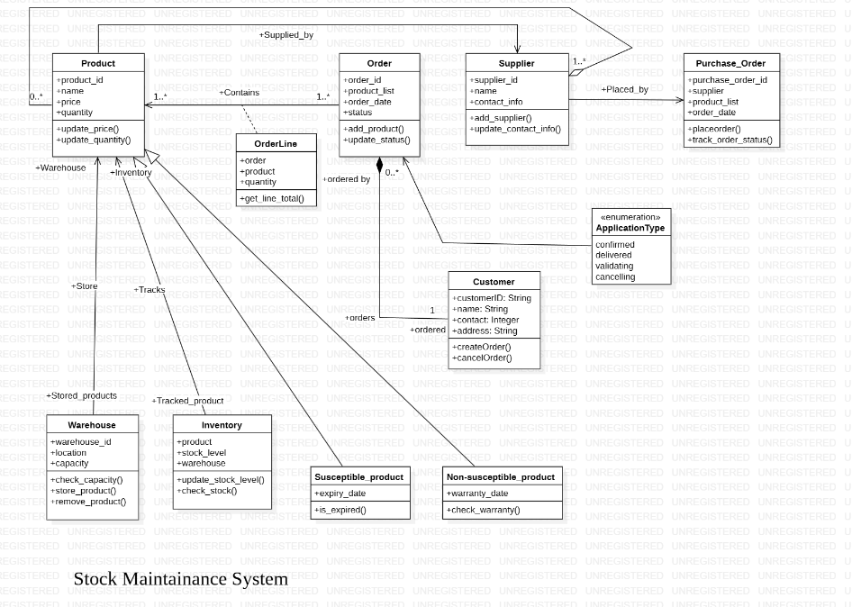

Fig 4.3.1

This represents a class diagram for a Stock Maintenance System. It models the relationships between various entities involved in managing stock, orders, and suppliers. Key entities include Product (with attributes like ID, name, price, and quantity, and operations to update price and quantity), Supplier (with name, contact information, and operations to add/update supplier details), Order (containing an order ID, product list, order date, and status, with operations to add products and update status), and Purchase_Order (linking suppliers to orders and tracking order status). An OrderLine class connects Order and Product, specifying the quantity of each product in an order. A Customer places orders and has attributes like ID, name, contact, and address. Warehouse stores products and has attributes for ID, location, and capacity, with operations to check capacity and manage stored products. The Inventory tracks the stock level of products in each warehouse. Finally, there are specialized product types: Susceptible_product (with an expiry date and an is_expired() operation) and Non-susceptible_product (with a warranty date and a check_warranty() operation), both inheriting from Product. The diagram shows the associations between these classes, illustrating the structure of the system and how different entities relate to each other in managing stock and orders.

* 1. State Diagram

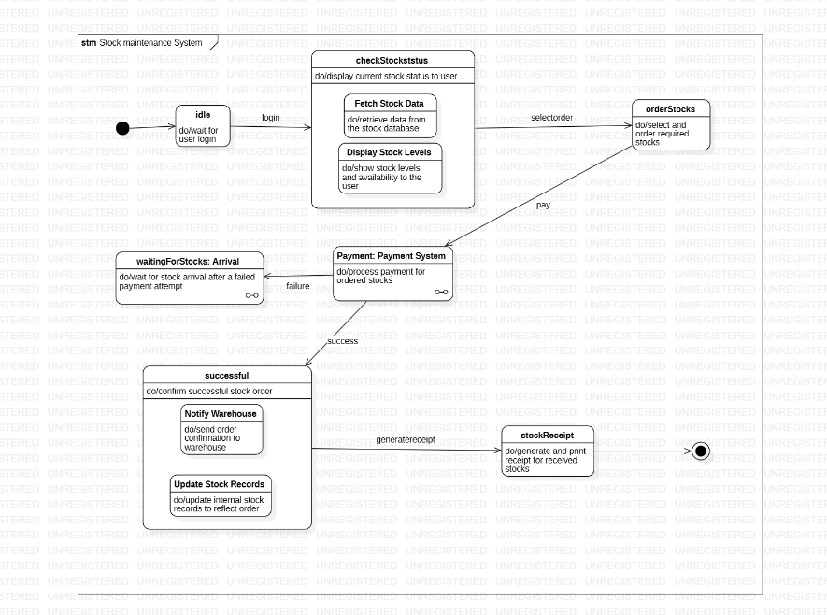

Fig 4.4.1

This state machine diagram represents the workflow of a stock maintenance system, detailing the various states and transitions involved in stock management. The process begins in an idle state, where the system waits for user login. Once authenticated, users can check the stock status, which involves fetching data from the stock database and displaying current stock levels and availability. After reviewing the stock, users can place orders by selecting the required items. Payment processing is handled through the payment system, with the outcome determining the next steps: a successful payment transitions to the successful state, while a failed payment leads to a waiting state where the system waits for the stock to arrive after retrying the payment. In the successful state, the system confirms the order by notifying the warehouse and updating internal stock records to reflect the new order. Finally, the system generates and prints a stock receipt for the ordered items, marking the end of the process. This diagram captures the seamless interaction between stock checking, ordering, payment, and stock record management.

4.5 Use Case Diagram

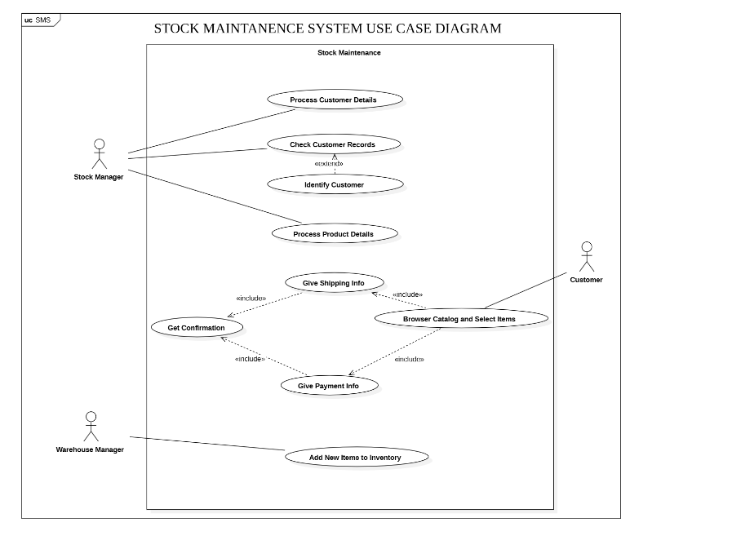

Fig 4.5.1

This use case diagram illustrates the interactions within a stock maintenance system, focusing on three main actors: the stock manager, customer, and warehouse manager. The stock manager oversees customer management by processing customer details, checking customer records, and identifying customers. They also handle product details and coordinate with customers by providing shipping information, receiving payment details, and confirming transactions. Customers actively participate by browsing the catalog, selecting items, providing shipping and payment information, and receiving confirmation. Meanwhile, the warehouse manager is responsible for adding new items to inventory, ensuring stock levels are maintained. The diagram highlights the collaboration between these actors and their roles in the stock management process, ensuring smooth and efficient operations.

4.6 Sequence Diagram

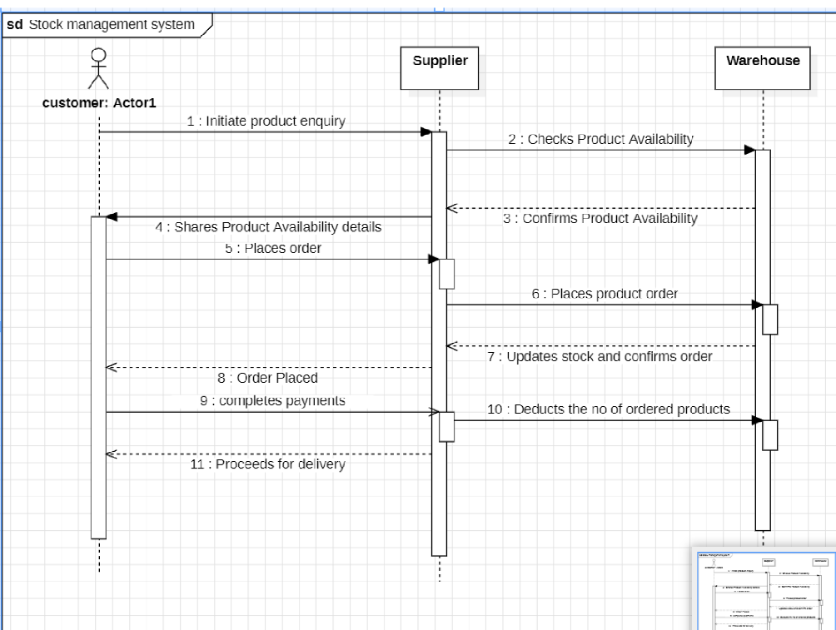

Fig 4.6.1

This sequence diagram illustrates the process flow in a stock management system involving three main entities: the customer, supplier, and warehouse. The interaction begins with the customer initiating a product inquiry, prompting the supplier to check product availability with the warehouse. The warehouse confirms availability to the supplier, who then shares the details with the customer. After reviewing the details, the customer places an order with the supplier. The supplier subsequently places the order with the warehouse, which updates stock records, confirms the order, and deducts the ordered quantity. Once the order is placed, the customer completes the payment, and the process proceeds to delivery. This diagram effectively captures the sequential actions and interactions ensuring smooth stock management.

4.7 Activity Diagram

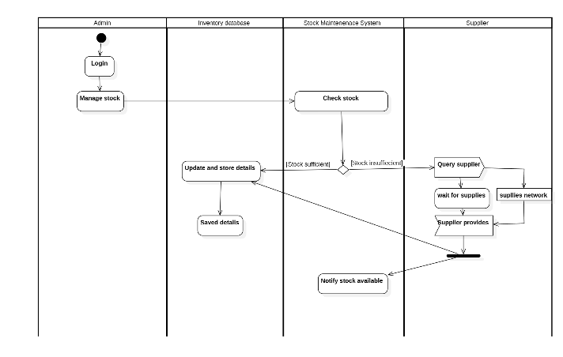

Fig 4.7.1

The diagram showcases a stock management process in a system with four key components: Admin, Inventory Database, Stock Maintenance System, and Supplier. It begins with the Admin logging into the system to manage stock. This triggers the Stock Maintenance System to check the stock levels in the Inventory Database. If the stock is sufficient, the system updates and stores the relevant details in the database, ensuring the Admin has the latest information. However, if the stock is found to be insufficient, the Stock Maintenance System communicates with the Supplier. This involves querying the Supplier to check availability and waiting for the supplies to be provided through the supplier's network. Once the Supplier fulfills the request and the stock is delivered, the system updates the inventory and notifies the Admin that the required stock is now available. This automated process ensures seamless coordination between different components for efficient inventory tracking and timely replenishment.

1. **Passport Management System**
   1. Problem Statement: Managing passport applications and issuance is a complex process involving multiple stages, including document verification, application tracking, and appointment scheduling. A streamlined system is required to handle these tasks efficiently, minimize errors, and enhance user experience.
   2. SRS-Software Requirements Specification

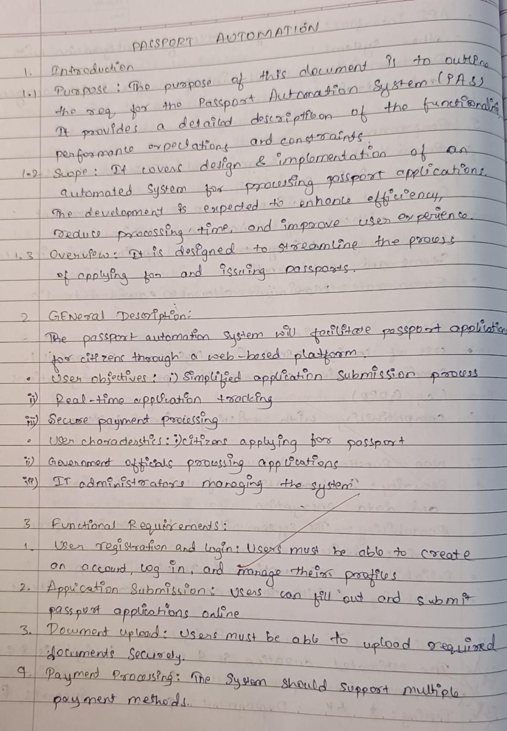

Fig 5.2.1

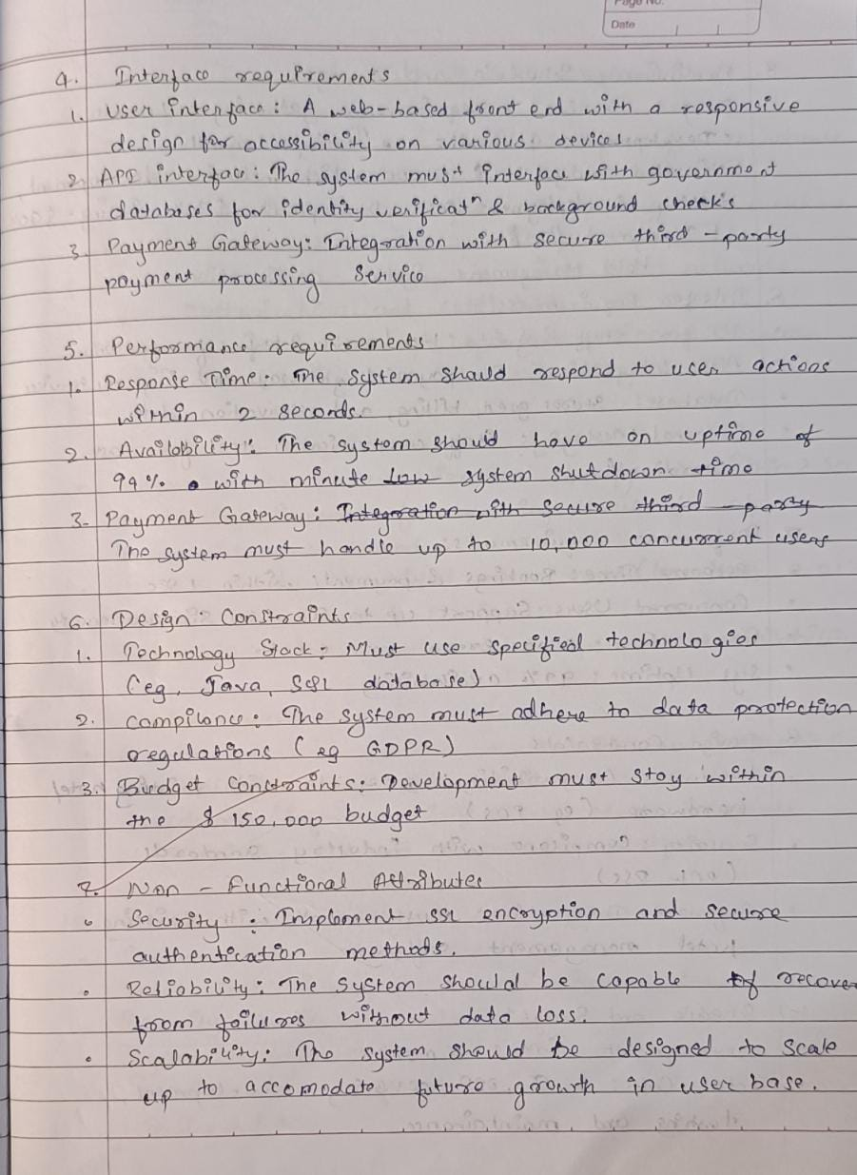

Fig 5.2.2

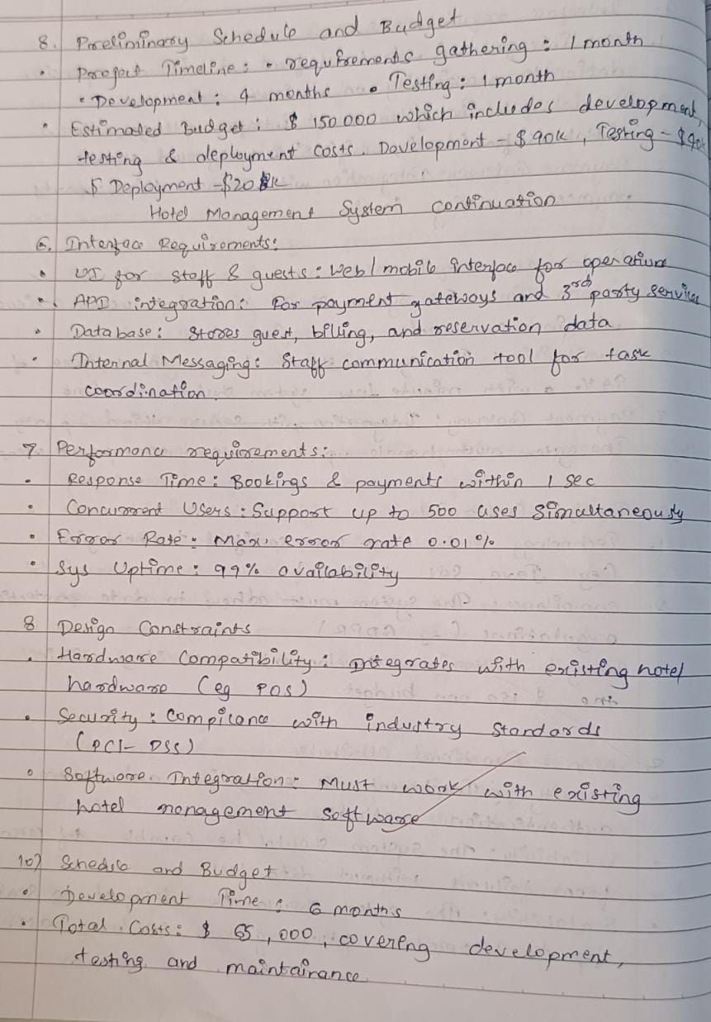

* 1. Class Diagram

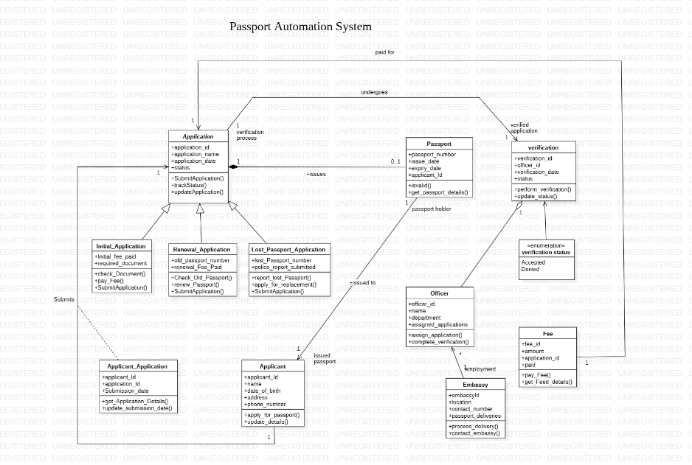

Fig 5.3.1

The Passport Automation System streamlines the end-to-end process of passport application, verification, and issuance by integrating multiple entities and workflows. Applicants can submit various application types, such as initial, renewal, or lost passport applications, each with specific requirements like document verification, fee payments, or police reports for lost passports. Applications are processed through a structured workflow where officers handle verification to ensure compliance. Approved applications result in passport issuance, with details such as passport number, issue, and expiry dates recorded. The system also tracks fee payments and facilitates passport delivery through the embassy. This automation ensures efficiency, transparency, and minimal delays in the passport issuance process.

* 1. State Diagram

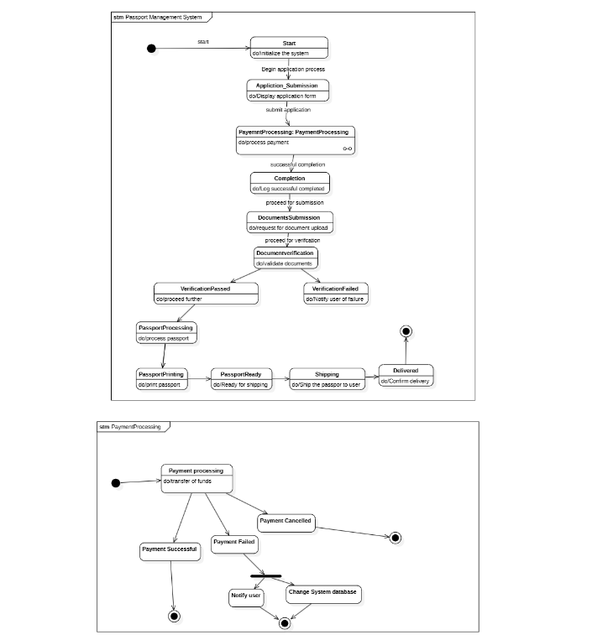

Fig 5.4.1

The diagram depicts the state model for a **Passport Management System** and its integrated **Payment Processing** system. The process begins with the initialization of the system, where users start the passport application process by submitting an application form. Following submission, the system transitions to payment processing, where funds are verified. Upon successful payment, the application proceeds to document submission and verification. If documents are verified successfully, the process moves forward to passport processing, printing, and preparing the passport for shipping. The final stage involves shipping the passport to the user and confirming delivery. In the Payment Processing subsystem, the flow handles various outcomes of payment transactions, including successful payment, failure, or cancellation, with corresponding system updates and user notifications. This state model ensures a structured, step-by-step approach to managing the passport application and delivery lifecycle.

* 1. Use Case Diagram

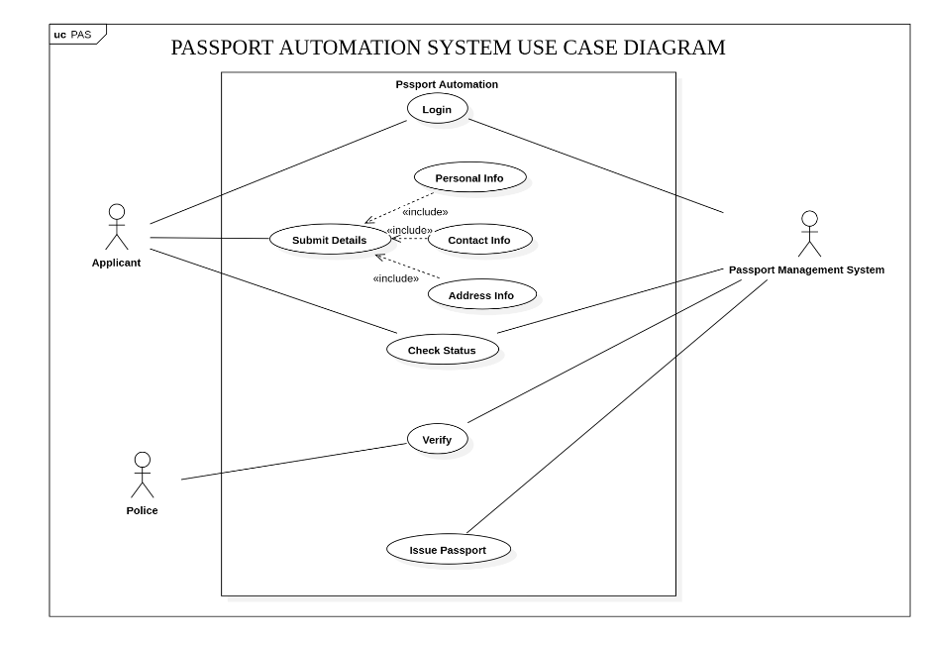

Fig 5.5.1

This use case diagram for a Passport Automation System. It illustrates the interactions between three actors: the Applicant, the Police, and the Passport Management System. The Applicant starts by logging into the system and proceeds to submit details, which include personal information, contact information, and address information. These are linked as separate use cases through the “include” relationship, signifying that they are essential steps in the process. The Applicant can also check the status of their application. The Police are involved in verifying the submitted details, a process connected to both the Applicant and the Passport Management System. Once the verification is completed, the system facilitates the issuance of the passport. The diagram effectively highlights the functional flow and dependency of activities within the automation system.

* 1. Sequence Diagram

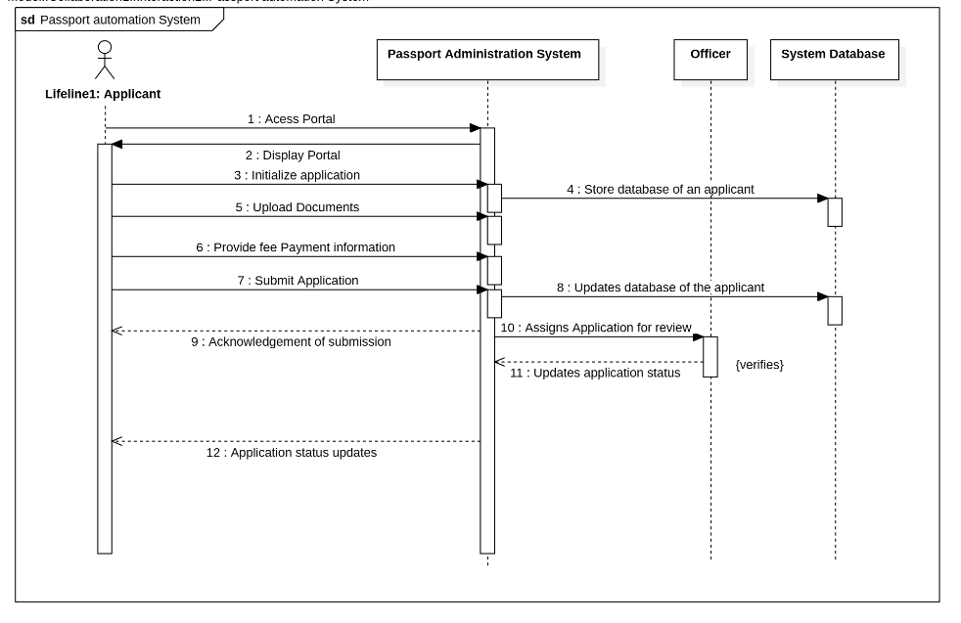

Fig 5.6.1

The sequence diagram illustrates the process flow in a Passport Automation System, involving four main entities: the Applicant, Passport Administration System, Officer, and System Database. The process begins with the Applicant accessing the portal (Step 1), which then displays the portal interface (Step 2). The Applicant initializes the application (Step 3), uploads the required documents (Step 5), and provides fee payment information (Step 6). The system stores the Applicant's details in the database (Step 4) and updates the application database after submission (Step 8). Once the Applicant submits the application (Step 7), they receive an acknowledgment of submission (Step 9). The application is then assigned to an Officer for review (Step 10), and the Officer verifies the information, updating the application status (Step 11). Finally, the Applicant receives updates regarding the status of their application (Step 12). This diagram effectively captures the sequential interactions and data flow between the entities involved.

* 1. Activity Diagram

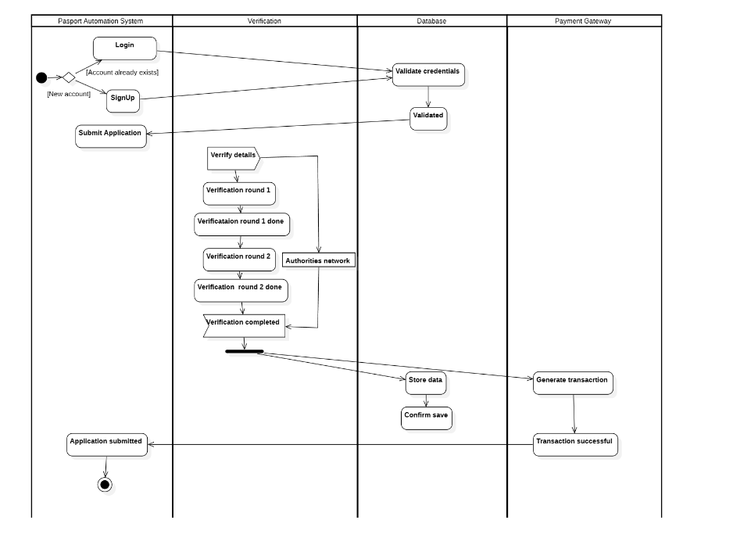

Fig 5.7.1

The activity diagram represents the workflow of a Passport Automation System, detailing the process across four primary components: Passport Automation System, Verification, Database, and Payment Gateway. It begins with a user decision between logging in (if an account exists) or signing up for a new account. Once authenticated through credential validation in the Database, the user submits an application. The Verification process involves two rounds of checks, including interaction with an authorities network, to ensure the details are accurate. After both rounds are completed, the application status moves to "Verification Completed." Simultaneously, the Database stores the data and confirms its integrity. In the Payment Gateway, a transaction is generated to complete the process, and upon successful payment, the application is officially submitted. This diagram clearly outlines the sequential and parallel actions, ensuring a comprehensive understanding of the system's operations.